Lab 9- Double Displacement Reactions Results

All chemicals used in this lab are aqueous solutions, except Na₂SO₃, which is a white powder.

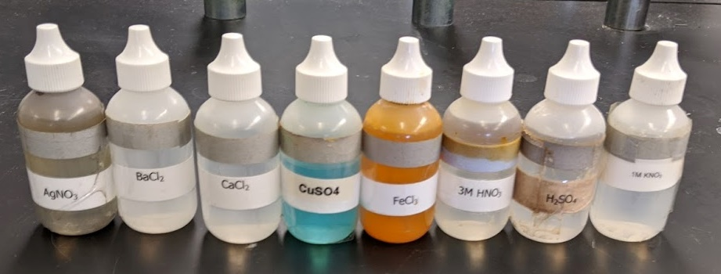
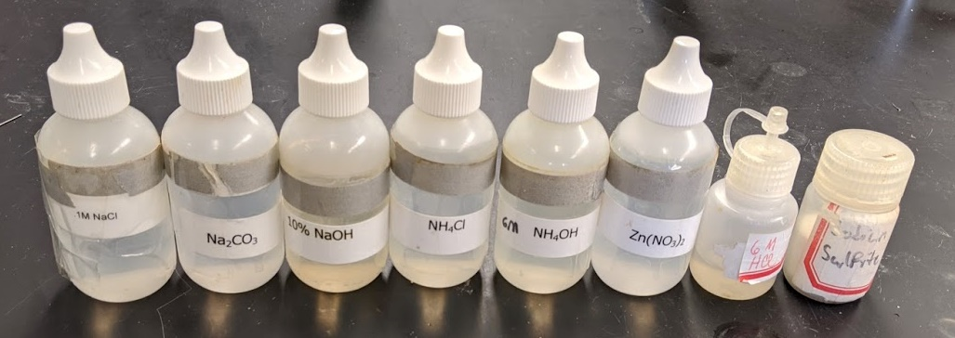

The solutions were mixed and appear on the next page. The combinations that produced heat or a gas are labeled, since that was difficult to see in a picture. The combinations which produced precipitates are clearly visible.
Use the information presented here for the observations section of the lab report and fill in the remaining report.
